Team 5

Team members :

* QLGOH0DDOD#IHVVXR\
* GHPKD#PDLUDP
* GHPDKRP#PDKVLK#GHPDKRP

Use the application below to find out who we are ;)

Encryption & Decryption

This application is a cipher which takes characters from a user and encrypts or decrypts it as you want to prevent other people to understand the meaning of it

The idea :

It takes the characters from the user and reverse the letters then change the asci value of each letter by 3 .

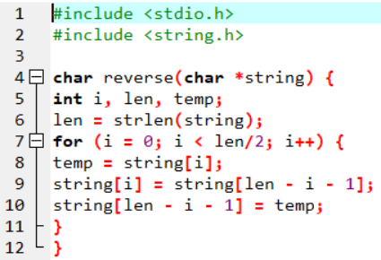

This part of the program is a function which take the characters from the user the reverse it

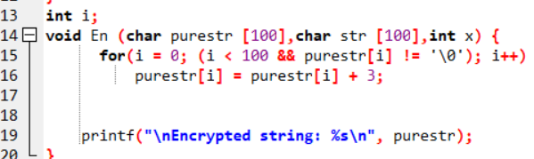

This part of the program is a function which take the characters from the user after reversing it then encrypt it

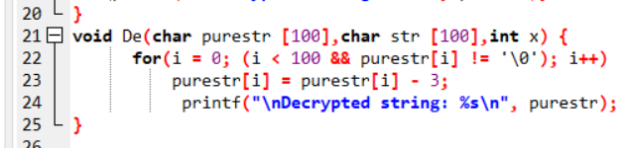

This part of the program is a function which take the reversed characters from the user then decrypt it to the original shape

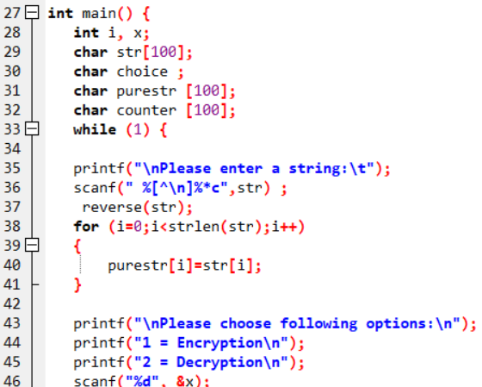

This is the main function which take the input from the user then ask him which operation does he want (Encryption & Decryption )

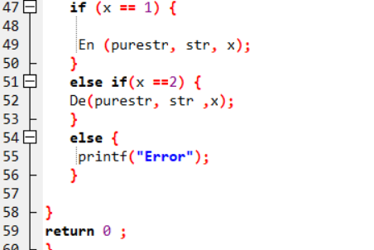

If the user pressed 1 that means that he wants to encrypt the characters or 2 to decryption the characters

Or other letter and that will give the user error .